CS 305 Project One

Document Revision History

Version | Date | Author | Comments
1.0 | 07/16/2026 | Austin Banks

Client



Instructions
Submit this completed vulnerability assessment report. Replace the bracketed text with the relevant information. In this report, identify your security vulnerability findings and recommend the next steps to remedy the issues you have found.

- Respond to the five steps outlined below and include your findings.
- Respond using your own words. You may also include images or supporting materials. If you include them, make certain to insert them in the relevant locations in the document.
- Refer to the Project One Guidelines and Rubric for more detailed instructions about each section of the template.

Developer
Austin Banks

1. Interpreting Client Needs
Determine your client’s needs and potential threats and attacks associated with the company’s application and software security requirements. Consider the following questions regarding how companies protect against external threats based on the scenario information:

- What is the value of secure communications to the company?
- Are there any international transactions that the company produces?
- Are there governmental restrictions on secure communications to consider?
- What external threats might be present now and in the immediate future?
- What modernization requirements must be considered, such as the role of open-source libraries and evolving web application technologies?

Secure communication is very valuable to Artemis Financial. It handles financial data that pertains to savings, retirement, investments, and insurance accounts. The company also operates a RESTful web API, which means that data travels across networks where interception of personal information is possible. Secure communication also contributes to customer trust, which is very valuable to this type of organization as well. A lack of secure communication could lead to identity theft and financial fraud for customers, and legal issues for Artemis Financial. This software will also serve government agencies which means it may handle the transmission of highly classified data. This company does produce international transactions because it serves entrepreneurs, businesses, and government agencies around the world. Since Artemis Financial will serve government agencies, there will be government restrictions to consider. These restrictions will influence how information is stored, transmitted, and protected through their software. Artemis Financial would face many external threats due to handling financial data from many different clients. This includes injection attacks due to improper input validation, denial of service attacks, and AI driven attacks as AI continues to evolve. Artemis Financial must modernize by adopting secure open-source libraries, using cryptography, and by utilizing security throughout the development life cycle.
2. Areas of Security
Refer to the vulnerability assessment process flow diagram. Identify which areas of security apply to Artemis Financial’s software application. Justify your reasoning for why each area is relevant to the software application.
Input validation- This applies to Artemis Financial’s software application because without effective input validation, attackers could inject harmful input that could corrupt financial data. Since this application is meant to handle sensitive financial information, this could compromise customer accounts. Effective input validation will ensure only safe data enters the application.

APIs- Artemis Financial relies on a RESTful web application programming interface to deliver financial information. It is important to have secure API Interactions so it does not succumb to excessive data exposure, broken authentication, injection flaws, and other threats.

Cryptography- Artemis Financial must protect sensitive financial information at rest and while in transit. Cryptography is important for this application to provide secure communication between clients and the server. The company specifically states that it wants to use the latest software security and protect the organization from external threats. Effective encryption is one of the most important aspects to protect data from external threats.

Client/Server- Client/Server is important because there must be trust between the client and the server which host the RESTful API. The server must validate all incoming data and treat every request as if it may be coming from an attacker. This is especially important for Artemis Financial because infiltration of client/server communication could lead to financial losses for the client.

Code Error- Code Errors are important to identify and fix for any software application. Code errors can lead to exposure of sensitive customer information. It can also lead to malfunctions in other parts of the application. In this scenario, one of my main roles it to identify security vulnerabilities in the application which includes code errors.

Code Quality- Code Quality is important because a lack of adhering to best coding practices can create vulnerabilities and make the system easier for attackers to infiltrate. Building quality code is a foundational tool that is important to any software application to make it easier to review and avoid unnecessary mistakes that could be detrimental to other security principles as well.

Encapsulation- This is important for Artemis Financial’s application to ensure that sensitive data such as account and customer information is protected from being modified by unauthorized individuals. For a financial organization, improper encapsulation can lead to unauthorized changes to customer accounts or corrupted data.

3. Manual Review
Continue working through the vulnerability assessment process flow diagram. Identify all vulnerabilities in the code base by manually inspecting the code.

[Include your 7–10 findings here.]
- Inconsistent naming practices. The “customer” and “myDateTime” classes do not follow java rules for naming classes. The first letter of each internal word should be capitalized. This a Code Quality violation.
- Class file DocData.java uses hard-coded credentials in “DriverManager.getConnection("jdbc:mysql://localhost:3306/test","root","root");”. This exposes the database if the code is leaked.
- The customer.java class file is missing a private access modifier to the “account_balance” field. This could allow an attacker to modify balances without going through validation.
- In the CRUDController.java class file, raw user input is accepted in “@RequestParam(value="business_name")” without any validation. This could be a risk for injection attacks.
- The myDateTime.java class file accepts any integers in the “setMyDateTime” method without any validation. This could cause further breaks in the system for sections that rely on accurate times.
- The DocData.java class file opens a database connection but does not close it. This is a code quality violation and code error violation.
- The customer.java class file has no input validation in the “deposit(int a) method. This could allow negative values to be put in for deposits to withdraw money. This is an input validation and code quality violation.

4. Static Testing
Run a dependency check on Artemis Financial’s software application to identify all security vulnerabilities in the code. Record the output from the dependency-check report. Include the following items:

- The names or vulnerability codes of the known vulnerabilities
- A brief description and recommended solutions provided by the dependency-check report
- Any attribution that documents how this vulnerability has been identified or documented previously
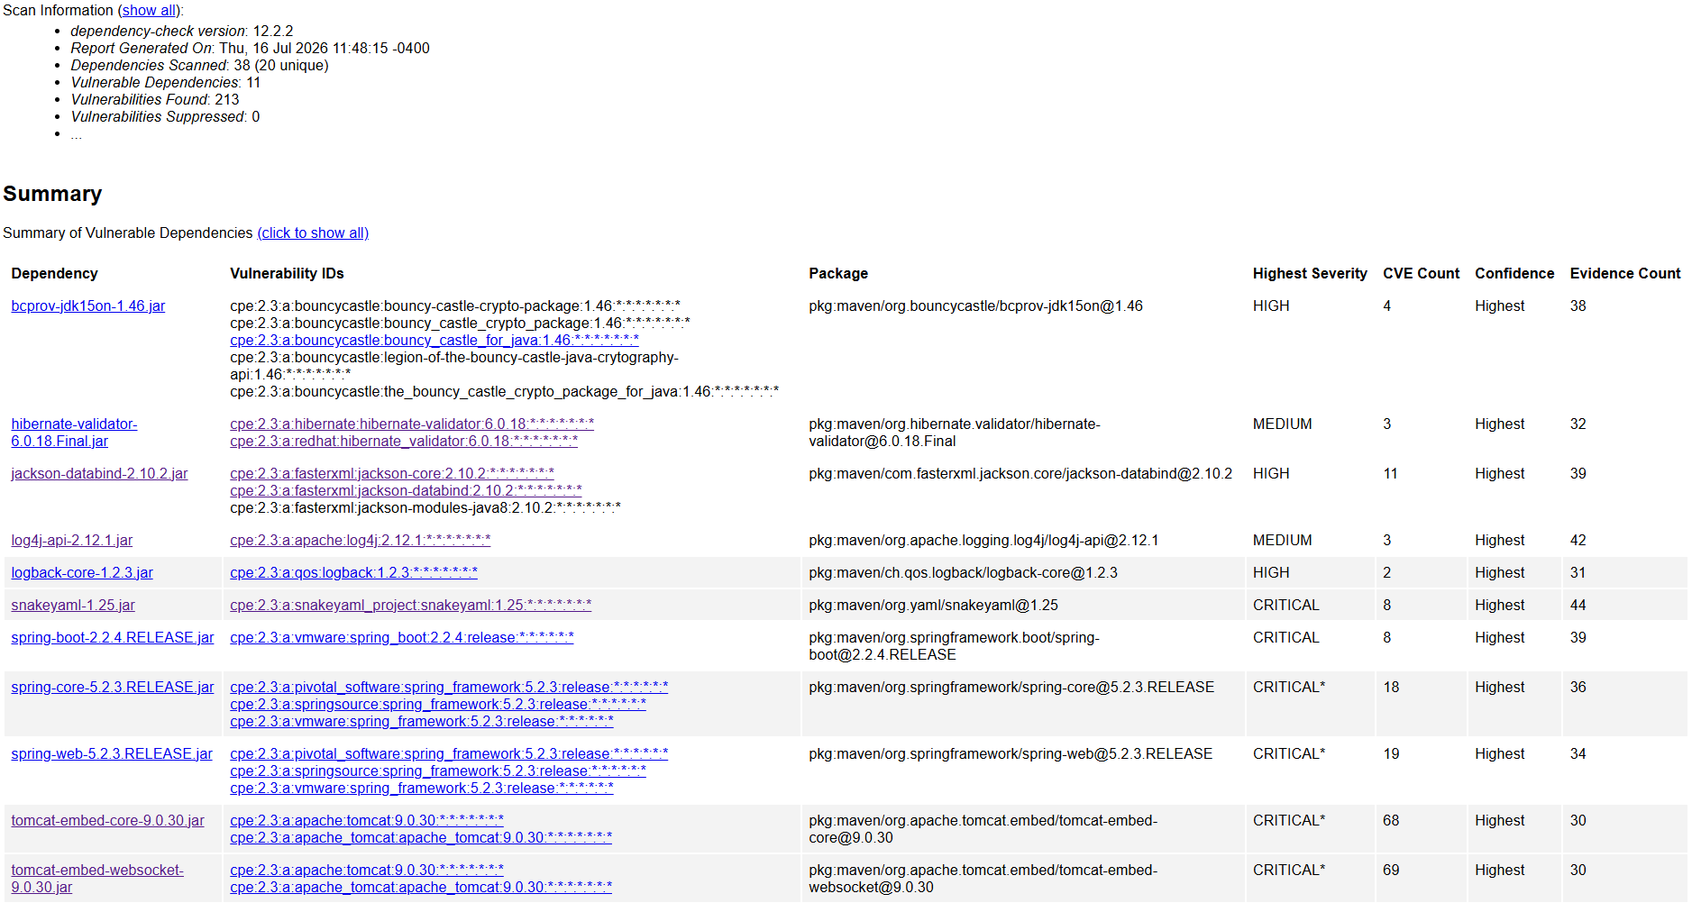

Dependencies

Bcprov-jdk15on-1.46.jar- The Bouncy Castle Crypto package is a Java implementation of cryptographic algorithms. This jar contains JCE provider and lightweight API for the Bouncy Castle Cryptography APIs for JDK 1.5 to JDK 1.7.
This dependency includes vulnerabilities that are subject to SQL injection, exposure of private key information, and denial of service attacks. The solution is to update to a version later than 1.8.6.

Hibernate-validator-6.0.18.Final.jar- Hibernate's Bean Validation (JSR-380) reference implementation.
This dependency includes vulnerabilities that are subject to arbitrary code execution, sensitive information access, HTML injection, and Cross-site-scripting attacks. The solution is to update to a version in between 6.2 and 7.0 or later than 7.0.

Jackson-databind-2.10.2.jar- General data-binding functionality for Jackson: works on core streaming API
This dependency includes vulnerabilities that are subject to validation bypass, XML external entity attacks, denial of service, and resource exhaustion. The solution is to update to version 3.1.4

Log4j-api-2.12.1.jar- The Apache Log4j API
This dependency includes vulnerabilities that are subject to malformed XML output and man-in-the-middle-attack. The solution is to update to version 2.25.4

Logback-core-1.2.3.jar- logback-core module
This dependency includes a vulnerability that is subject to arbitrary code execution. The solution is to update to version to at least version 1.2.8 but exclude 1.4.11 to avoid another vulnerability.

Snakeyaml-1.25.jar- YAML 1.1 parser and emitter for Java
This dependency includes vulnerabilities that are subject to remote code execution, entity expansion, denial of service, and denial of service attacks. The solution is to update to version 2.0 and beyond.

Spring-boot-2.2.4.RELEASE.jar- Spring Boot
This dependency includes vulnerabilities that are subject to security bypass, authentication bypass, directory hijacking, denial of service attacks, remote code execution, user hijack, and file corruption . The solution is to update to version 4.0.6

Spring-core-5.2.3.RELEASE.jar- Spring Core
This dependency includes vulnerabilities that are subject to remote code execution, SSRF attacks, open redirect attack, privilege escalation, RFD attacks, denial of service, denial of service attacks, disk space attack, disclosure of content, malicious input, escalation attack, cache poisoning, and stream corruption . The solution is to update to version 5.3.7

Spring-web-5.2.3.RELEASE.jar- Spring Web
This dependency includes vulnerabilities that are subject to remote code execution, SSRF attacks, open redirect attack, privilege escalation, RFD attacks, denial of service, denial of service attacks, disk space attack, disclosure of content, malicious input, escalation attack, cache poisoning, and stream corruption . The solution is to update to version 5.3.7

Tomcat-embed-core-9.0.30.jar- Core Tomcat Implementation
This dependency includes vulnerabilities that are subject to remote code execution, authentication bypass, remote code execution, bypass of rules, server unresponsiveness, denial of service, and information leak. The solution is to update to version 9.0.99.

Tomcat-embed-websocket-9.0.30.jar- Core Tomcat Implementation
This dependency includes vulnerabilities that are subject to remote code execution, authentication bypass, remote code execution, bypass of rules, server unresponsiveness, denial of service, and information leak. The solution is to update to version 9.0.99.

5. Mitigation Plan
Interpret the results from the manual review and static testing report. Then identify the steps to mitigate the identified security vulnerabilities for Artemis Financial’s software application.

- Inconsistent naming practices in customer.java and myDateTime.java can be mitigated by simply changing the class names to Customer and MyDate Time and update the references to these classes throughout the application.
- Hard coded credentials in DocData.java can be mitigated by using Sprin Boot’s secure configuration for customer credentials.
- Missing private access modifier for account_balance in customer.java can be mitigated by changing it to private int account_balance.
- Raw user input without validation in CRUDcontoller.java can be mitigated by adding sanitizing the input before use and rejecting unexpected input.
- Unvalidated time values in myDateTime.java can be mitigated by adding acceptable ranges for the seconds, minutes, and hours fields. It should also throw exceptions for invalid values.
- Database connection not being closed in DocData.java can be mitigated by closing the connection.
- No input validation in the deposit method in customer.java can be mitigated by validating the deposit amount and throwing an exception if it is less than 0.
- The dependency vulnerabilities can all be mitigated by updating to the specified versions in the previous section.

